W150D-How to set a password for wireless network?
Product line: ADSL Question category: Wireless settings

Q: Why we need to set a password for our wireless network?
A: sometimes we don’t want others to use your wireless network then you can set a password for your wireless network
I. Physical connection:
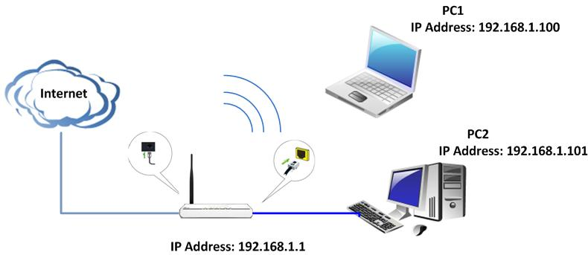
II. Login to the management page of the router:
1、open your web browser(IE,Firefox,Safari,etc) →find the address bar→leave it blank→type 192.168.1.1→Press enter.
(Care: The address bar is in the most top of the web page after opening web browser).
2、Then you can see the following page, chick on Advanced Settings.
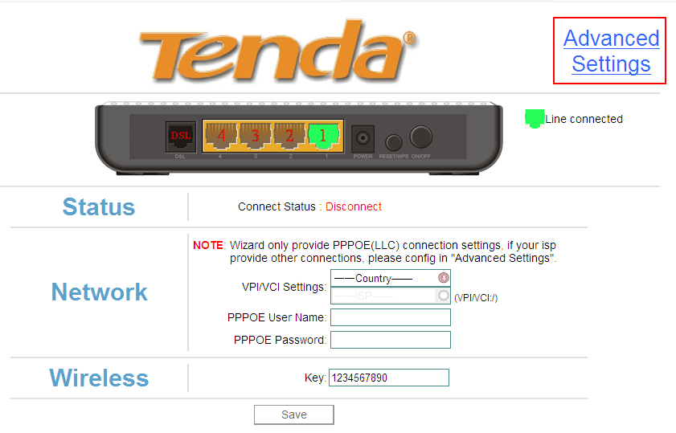
3、After clicking Advanced Settings，you will see the follow page
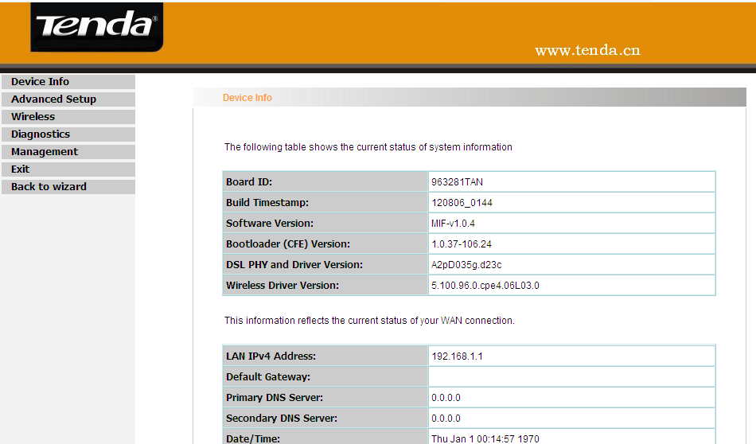
III、Steps to do wireless settings
1、click on wireless –>basic on the left menu ,please change SSID (it is your wireless network name)for other name, and then held on Apply
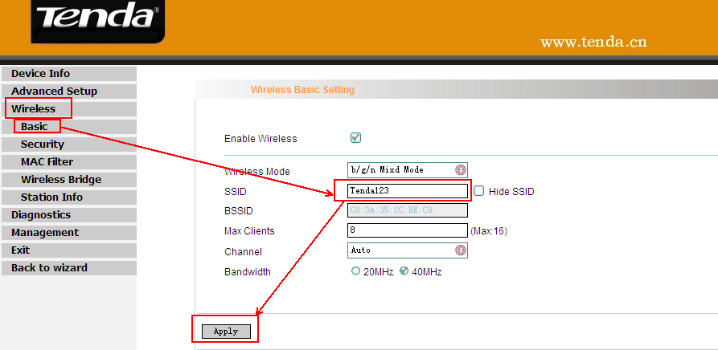
1、click on wireless –>security on the left menu ,please disable WPS setting ,select Network Authentication to WPA-PAK or WPA2-PSK,change WPA Encryption to AES, and then WPA passphrase ( please type in at least 8 numbers or letters).
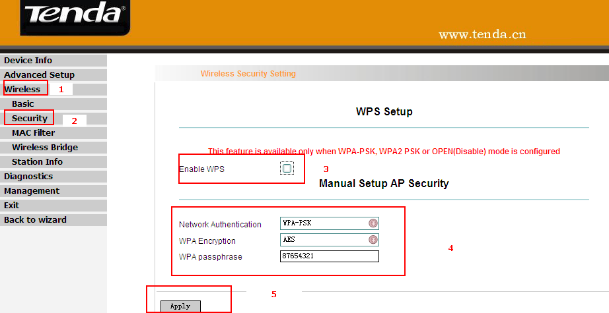
IV. Connect computers to Internet wirelessly.
Please find the name of your wireless network (it is SSID which is your family name) and connect to it. It will require you to input password, please type password (It is the passphrase which was made by yourself just now.)

When your SSID (wireless network) shows connected, that means you can access to the Internet wirelessly, now you can try to unplug the cable between your computer and your tenda router to see if you can enjoy your Internet wirelessly.

